Document Information
Document Identification | Data Model Document for Intellicue 3.1
Document Name | Intellicue 3.1 Data Model
Master Copy
Electronic File Name | Intellicue 3.1-DMD v0.9.doc
Version Number | 0.9
Issue Date
Authored by | Pawan Aggarwal
Reviewed by | Pradeep Chadda,  Harvinder Kumar
Approved by

Version History
VERSION &  DATE | PREPARED / REVISED BY | REASON FOR CHANGE
Draft Version | Pawan Aggarwal | New fields for Intellicue 3.1
Review Changes incorporated | Pawan Aggarwal | Review
1.0 | Pawan Aggarwal | Baseline Release



HCL Perot Systems
Plot No.3, Sector 125
NOIDA - 201301, India

This is a controlled document if it bears controlled stamped in red. Unauthorized access, copying and replication is prohibited. This document must not be copied in whole or part by any means, without the written authorization of Head of Quality Assurance Group, HCL Perot Systems.

CONTENTS
Data Model for Intellicue (inclusive of ExecMap + SM) 4

Tables 7
1. Intellicue System Table (intellicue_sys_mas) 7
2. Account Master (acct_mas) 7
3. Individual Account (ind_acct_mas) 8
4. Billing Details (bill_det) 9
5. Company Account (co_acct_mas) 9
6. Company Group (co_grp_mas) 10
7. Company User (co_usr_mas) 10
8. Activity Role Type (actv_rol_mas) 11
9. Activity type (actv_mas) 11
10. Role Activity Relation (rol_actv_rel) 11
11. Personal Info Field Master (per_info_fld_mas) 12
12. Personal Info Access Role Type (per_info_rol_mas) 12
13. Personal Info Role Field Relation (per_info_rol_fld_rel) 12
14. Career Group (car_grp_mas) 12
15. Career Group Access Role Type (car_grp_rol_mas) 13
16. Career Group Access Role Relation (car_grp_rol_rel) 13
17. Qualification Type (qual_mas) 13
18. Test Category Type (test_cat_mas) 13
19. Sub Category Type (sub_cat_mas) 14
20. Sub Category Detail (sub_cat_det) 14
21. (SOI) Trigram Type (tri_mas) 14
22. Conversion Matrix for stanine score (stan_scr_conv_mat) 15
23. Skill Type (skill_mas) 15
24. Skill Trigram Relation (skill_tri_rel) 15
25. Skill group (skill_grp_mas) 15
26. Skill group Skill Relation (skill_grp_skill_rel) 16
27. Skill Group Condition Relation (skill_grp_cond_rel) 16
28. Career Type (car_mas) 16
29. Customized Career Type (custom_car_mas) 16
30. Career Skill Relation (car_skill_rel) 17
31. Customized Career Skill Relation (custom_car_skill_rel) 17
32. Ability Type (abil_mas) 17
33. Ability Skill Relation (abil_skill_rel) 17
34. Sub test type (sub_test_mas) 17
35. Category Sub Test Relation (cat_sub_test_rel) 18
36. Sub Test Corrective Template (sub_test_correc_temp) 18
37. Category Activity Relation (cat_actv_rel) 18
38. Test Session (test_ses_mas) 19
39. Test Session Score (test_ses_scr_det) 19
40. Skill Score (test_ses_skill_scr_det) 20
41. Skill Level Trigram Relation (skill_lvl_tri_rel) 20
42. Report Paragraph Master (rpt_para_mas) 20
43. Report Paragraph Detail (rpt_para_det) 20
44. Discount Detail (Discnt_Det) 21
45. Deny reports to groups and users (Deny_Reports) 21

New Tables Added to Existing Database 21
46. User Prescription Table (sm_usr_pres) 21
47. Impact Description(sm_impact_desc) 21
48. Impact Rules(sm_impact_rule) 22
49. Score Table(sm_score) 22
50. SmartMod Master(sm_mas) 22
51. Activity Master(sm_act_mas) 22

Stored Procedures 24
1. IntelMail 24

New Procedures Identified 24
2. Notification Mail To User 24
3. Informing user that account has been extended. 25

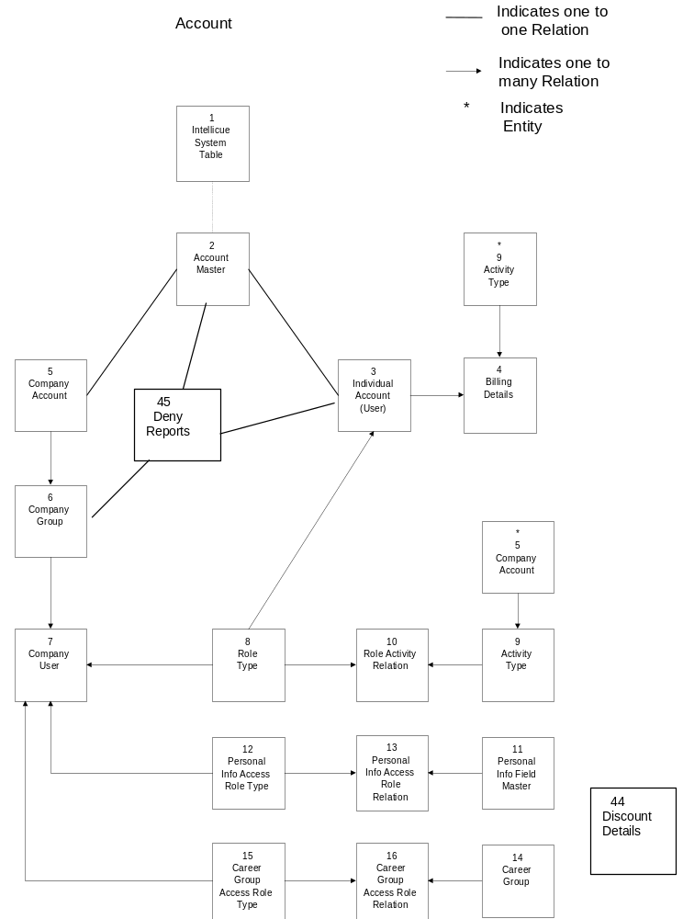Data Model for Intellicue (inclusive of ExecMap + SM)

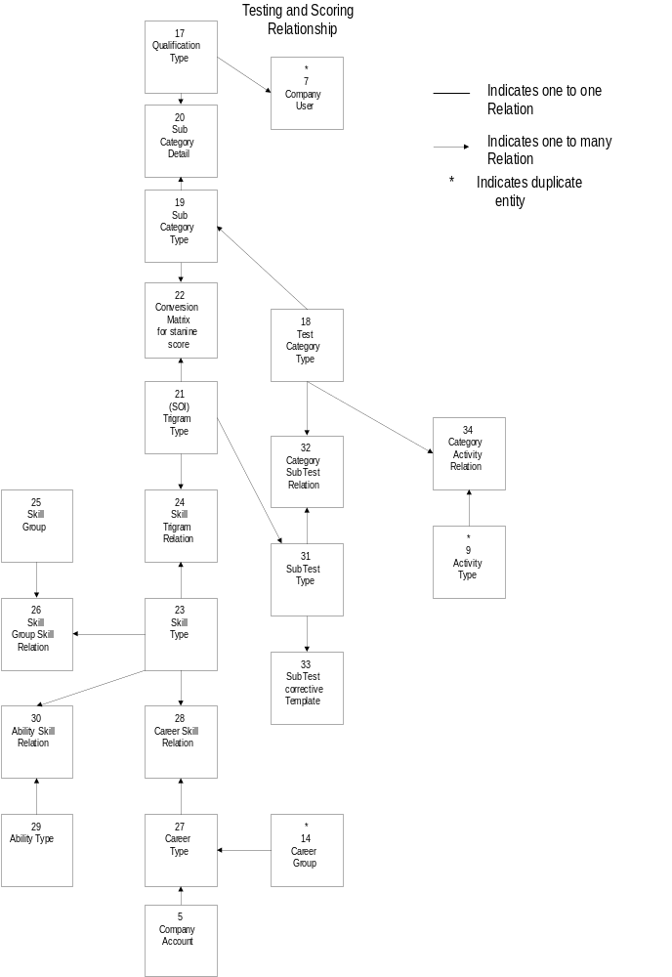
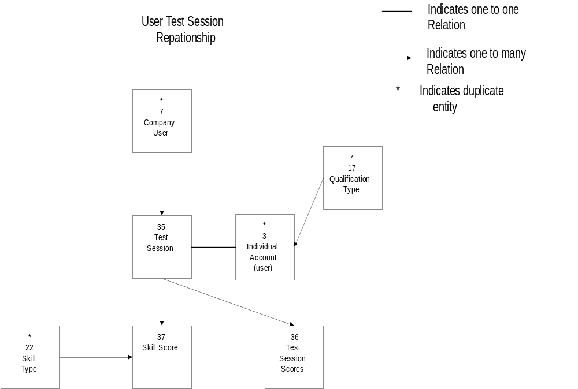

Tables
Note:
- * indicates Primary key field
- All grayed columns are new columns added to existing tables

Intellicue System Table (intellicue_sys_mas)
This table has following attributes:
Attribute Data Type
- Last Account no. int
- Max time period for company account smallint
- Max time period for individual account smallint
- Time period for intimation mail smallint
- Sailing through low value decimal(5,2)
- Sailing through high value decimal(5,2)
- Sailing through period smallint
- Sailing through test smallint
- Test Duration smallint
- Intellicue Admin Account Id char(10)
- Intellicue Admin user Id char(15)
- Intellicue Admin Password char(15)
- Billing amt for the test money
- Billing amt for SOI reports money
- Billing amt for Careercue money
- SmartMod sale price money
- SmartMod Extension smallint
- Fail criteria smallint
- Max. Question attempt smallint
- Notification period smallint
- Qualifying Score smallint
- Sigma Factor decimal(5,2)
- CareerCue Search Range smallint
- CareerCue Person Search Range smallint
- SM subscription Price money

This table is used to store some of the global settings used by the application. It contains only one record. It has 22 attributes. This table is populated at the time of system setup. The attribute ‘sailing through low value’ indicates that if the user gets marks equal or less than this value in two consecutive tests then system will present sub-tests of lower test category. The attribute ‘sailing through high value’ indicates that if the user gets marks equal or higher than this value in two consecutive tests then system will present sub-tests of higher test category. The attribute ‘sailing through period’ indicates that if the user completes this period then sailing through will not be possible and the user has to complete the sub tests of the same category. The attribute ‘sailing through test’ indicates that if user finishes the number of tests equal to or higher than this value then sailing through will not be possible. ‘Test duration’ indicates the time period allowed to the testee to complete the assessment. In addition to this, Intellicue admin account id, user id and password are also stored in this table. Billing amount charged for test, SOI reports and career cue are also stored here. Option to change any of the above information is available in the application.

Account Master (acct_mas)
This table has following attributes:
Attribute Data Type
- Account id * char(10)
- Account type char(1)
- Valid from date datetime
- Valid to date datetime
- Last modified date datetime
- Last session no int
- Creation date datetime
- Expiry intimation flag char(1)
- Intimation sent date datetime
- Status char(1)

This table has 10 attributes. Its primary key is account id. This table holds common information about company and individual accounts. This table has one to one relationships with company and individual account. Intellicue administrator populates all the attributes at the time of account creation with a GUI. The attribute ‘account type’ has three values either ‘C’ or ‘I’ or ‘A’. Account type ‘C’ is for company account, ‘I’ is for individual account and ‘A’ for Admin account. By default ‘expiry intimation flag’ is set to True. A daily scheduled job will send an intimation mail to the group supervisor and Intellicue administrator two weeks prior to account ‘valid to date’ for company account only. Intellicue administrator can set this flag to prevent intimation mail. Intellicue administrator will set the attribute ‘status’ if he wants to disable a account.

Individual Account (ind_acct_mas)
This table has following attributes:
Attribute Data Type
- Account id * char(10)
- User id nvarchar(15)
- Name nvarchar(50)
- Password nvarchar(15)
- Address1 nvarchar(40)
- Address2 nvarchar(40)
- City nvarchar(25)
- State nvarchar(25)
- Country nvarchar(25)
- zip nvarchar(15)
- Email nvarchar(40)
- Phone nvarchar(40)
- Fax nvarchar(40)
- Type of job nvarchar(40)
- Date of birth datetime
- Qualification id smallint
- Educational qualification nvarchar(50)
- Professional qualification nvarchar(50)
- Activity role id smallint
- Start Flag char(1)
- Extend_days smallint
- ReminderPhrase nvarchar(50) NULL
- Auto Extension Flag char(1)
- Credit Card Number varchar(150)
- Credit Card type varchar(10)
- Credit Card type expiry date
- SM Subscription Rate money

This table has 27 attributes. Its primary key is account id. This table holds all the information about an individual user. This table has one to one relation with account master. Each individual user is assigned to one role so that he can perform activities related to that role. Individual user populates all the attributes at the time of account creation with a GUI.
Start Flag is used to decide whether an Individual user can retake test or not. If the value is “T” it means the Individual user is allowed to take test, if it is “F” the Individual user is not allowed to retake test.

Billing Details (bill_det)
This table has following attributes:
Attribute Data Type
- Account id * char(10)
- Activity id * smallint
- Billing date * datetime
- Amount money
- Authorization Code char(6)
- PNR Reference char(12)

This table has 4 attributes. Its primary key is account id, activity id and billing date. It contains billing information related to individual users only.

Company Account (co_acct_mas)
This table has following attributes:
Attribute Data Type
- Account id * char(10)
- Name nvarchar(50)
- Company info nvarchar(50)
- Cobrand Info nvarchar(50)
- Address1 nvarchar(40)
- Address2 nvarchar(40)
- City nvarchar(25)
- State nvarchar(25)
- Country nvarchar(25)
- zip nvarchar(15)
- Email nvarchar(40)
- Phone nvarchar(40)
- Fax nvarchar(40)
- Tax id nvarchar(30)
- POC Name nvarchar(50)
- Billing address 1 nvarchar(40)
- Billing address 2 nvarchar(40)
- Billing City nvarchar(25)
- Billing State nvarchar(25)
- Billing Country nvarchar(25)
- Billing zip nvarchar(15)
- Billing Email nvarchar(40)
- Billing phone nvarchar(40)
- Billing Fax nvarchar(40)
- Cust_rpt char(1)
- Cust_car_cue char(1)
- Welfare_flg char(1)
- Disclaimer char(1)
- Execmap_flg char(1)
- Smart Mod Access char(1)
- par_eval_rep_type varchar(15) Default “NotApplicable”
- exec_rep_format varchar(15) Default “NotApplicable”

This table has 32 attributes. Its primary key is account id. This table holds all the information about companies. This table has one to one relations with account master and one to many relationships with company groups because a company can have many groups. In practice generally groups means departments exist within a company. Intellicue administrator populates all the attributes at the time of account creation with a GUI. The attribute par_eval_rep_type will identify the format of the Evaluator reports for the General Companies. The possible values for this are ‘Long’, ‘Short’ or ‘NotApplicable’. The attribute exec_rep_format will identify the format of the ExecMap report available to the corporate user i.e. whether it is Managerial or Leadership report. The possible values for this are ‘Managerial’, ‘LeadershipA’, ‘LeadershipE’ or ‘NotApplicable’.

Company Group (co_grp_mas)

This table has following attributes:
Attribute Data Type
- Account id * char(10)
- Group id * char(15)
- Group info varchar(40)
- Date last modified datetime
- Status char(1)
- Group_email nvarchar(40)
- SmartMod Group Access char(1)

This table has 7 attributes. Its primary key is account id and group id. This table holds all the information about company groups. This table has one to many relationships with company accounts and company users because a company can have many groups and a group (departments) can have many users (employees). All the attributes are populated at the time of group creation with a GUI by Intellicue administrator (On request from company) or by company supervisor or Group coordinator. Intellicue administrator or Group supervisor will set the attribute ‘status’ if he wants to disable a group. The attribute Group_email contain the group e-mail ID to which the skill score difference has to be sent.

Company User (co_usr_mas)
This table has following attributes:
Attribute Data Type
- Account id * char(10)
- Group id * char(15)
- User id * nchar(15)
- Password nvarchar(15)
- Name nvarchar(50)
- Type of Job nvarchar(40)
- Qualification id smallint
- Educational qualification nvarchar(50)
- Professional qualification nvarchar(50)
- Date of birth datetime
- Activity role id smallint
- At risk flag char(1)
- Phone nvarchar(40)
- Email nvarchar(40)
- Last modified date datetime
- Personal info access role smallint
- Career-cue access role smallint
- Status char(1)
- Start/Restart Flag char(1)
- Notes1 nvarchar(125)
- Notes2 nvarchar(125)
- Reminder Phrase nvarchar(50)

This table has 21 attributes. Its composite primary key is account id, group id and user id. This table holds all the information about company users. Each user is assigned to a group and a role. Each user belongs to a test category based on his qualification and age or based on at risk category. All the attributes are populated at the time of group creation with a GUI by Intellicue administrator (On request from company) or Supervisor or Group coordinator. The attribute ‘at risk flag’ is set by Intellicue administrator (on request from company) or Group supervisor if he thinks that a company user has intellectual level far below than what should be expected for the given age or education level. Intellicue administrator or supervisor or Group coordinator will set the attribute ‘status’ if he wants to disable a user account. Attributes ‘Notes1’ and ‘Notes2’ are used to store any additional info about the user. Start/Restart flag is modified only by the system or the supervisor if a testee wants to avail a second chance to take the assessment.

Activity Role Type (actv_rol_mas)

This table has following attributes:
Attribute Data Type
- Activity role id * smallint
- Description varchar(40)

This table has 2 attributes. Its primary key is role id. This table holds all the available roles in the system. Each user is assigned to a role. For example user may be Intellicue administrator, group supervisor or coordinator or company testee or individual user A role can perform many activities. For example a group coordinator may perform activities like user account creation or user account modification etc. A role can access only those reports, which he is authorized to access.

Activity type (actv_mas)
This table has following attributes:
Attribute Data Type
- Activity id * smallint
- Parent activity id * smallint
- Account id * char(10)
- Activity type char(1)
- Amount money
- Description varchar(40)

This table has 6 attributes. Its primary key is activity id. This table holds information about all type of functions that system can perform with user interface. For example create group, create user, take a test, etc.

Role Activity Relation (rol_actv_rel)

This table has following attributes:
Attribute Data Type
- Activity role id * smallint
- Activity id * smallint

This table has 2 attributes. Its primary key is role id and activity id. This table holds information about what all activities can be performed by different roles. A role can perform many activities. For example a group coordinator may perform activities like user account creation or user account modification etc.

Personal Info Field Master (per_info_fld_mas)
This table has following attributes:
Attribute Data Type
- Personal info field id * char(40)
- Personal info field description nvarchar(40)

This table has 2 attributes. Its primary key is field id. This table contains all the fields related to personal info that a company user can change. For example qualification id, professional qualification, type of job etc.

Personal Info Access Role Type (per_info_rol_mas)

This table has following attributes:
Attribute Data Type
- Personal Info Role id * smallint
- Description varchar(40)

This table has 2 attributes. Its primary key is role id. This table holds all the available roles in the system. Each user is assigned to a role.

Personal Info Role Field Relation (per_info_rol_fld_rel)
This table has following attributes:
Attribute Data Type
- Personal Info Role id * smallint
- Personal info field id * char(40)

This table has 2 attributes. Its primary key is personal info role id and field id. This table holds information about what all fields in profile can be changed by different roles. This table has one to many relationships with Personal info field master and personal info role master.

Career Group (car_grp_mas)
This table has following attributes:
Attribute Data Type
- Career group id * smallint
- Description varchar(40)

This table has 2 attributes. Its primary key is career group id. Each career belongs to a career group. A career group may be like professional, vocational, executive etc.

Career Group Access Role Type (car_grp_rol_mas)

This table has following attributes:
Attribute Data Type
- Career group access role id * smallint
- Description varchar(40)

This table has 2 attributes. Its primary key is career group access role type role id. This table holds roles related to career groups.

Career Group Access Role Relation (car_grp_rol_rel)
This table has following attributes:
Attribute Data Type
- Career group access role id * smallint
- Career group id * smallint

This table has 2 attributes. Its primary key is career group access role id and career group id. This table has one to many relationships with career group master and career group access role master.

Qualification Type (qual_mas)
This table has following attributes:
Attribute Data Type
- Qualification id * smallint
- Description varchar(40)

This table has 2 attributes. Its primary key is qualification id. This table contains all possible qualifications from kindergarten to PhD. Each user will select one of the possibilities to store his highest qualification.

Test Category Type (test_cat_mas)
This table has following attributes:
Attribute Data Type
- Category id * smallint
- Category Sequence id smallint
- Description varchar(40)
- Sequence type indicator char(2)

This table has 4 attributes. Its primary key is category id. This table contains 11 possible categories. For company user test category is selected based on age and qualification or at risk category. For an individual user, test category is selected based on age and qualification only, category at risk is not applicable for a individual user. Based on test category sets of sub-tests are selected. Each category has one or many subcategories. For example category K3 has subcategories k, 1, 2,3.
The attribute ‘category sequence id’ is used in cases where a user is getting 100% marks in two continuous sub tests or getting 0% marks in two continuous sub tests (It is called sailing through cases). If he gets 100% marks in two continuous sub tests then system will give him sub-tests of higher category and if he gets 0% marks in two continuous sub tests then system will give him sub-tests of lower category according to category sequence id. This is not applicable for at risk categories.
The attribute ‘sequence type indicator’ tells whether sailing through case is applicable to that category or not. For example in case of at risk youth, at risk adult and occupation retrain sailing through is not applicable. It also indicates which type of sailing through is applicable for highest and lowest categories. For example, if a user is appearing in test with Business test category and he gets 100% marks in two consecutive sub-tests then the system cannot offer him higher category sub-tests because Business is the highest category available in the system but if he gets 0% marks in two continuous sub-tests then system will present him sub-tests of lower category. Opposite is true if user is appearing with the lowest category.

Sub Category Type (sub_cat_mas)
This table has following attributes:
Attribute Data Type
- Category id * smallint
- Sub Category id * smallint
- Description varchar(40)

This table has 3 attributes. Its primary key is category id and Sub Category id. Based on age and qualification each company/individual user belongs to a sub category. Based on test category, sub category and trigram a rule is selected to convert raw score to stanine score. Each category has one or many subcategories. For example in category K3, subcategory k, 1, 2,3 exist. For each subcategory conversion rules exist for each trigram.

Sub Category Detail (sub_cat_det)
This table has following attributes:
Attribute Data Type
- Category id * smallint
- Sub Category id * smallint
- Qualification id * smallint
- Age lower limit smallint
- Age upper limit smallint

This table has 5 attributes. Its primary key is category id, sub Category id and qualification. Based on age and qualification each company/individual user belongs to a sub category. Based on test category, subcategory and trigram, a rule is selected to convert raw score to stanine score. Each category has one or many subcategories. For example in category K3, subcategory k, 1, 2,3 exist. For each subcategory conversion rules are exist for each trigram..

(SOI) Trigram Type (tri_mas)
This table has following attributes:
Attribute Data Type
- Trigram id * char(4)
- What is tested varchar(50)
- What it impacts varchar(50)
- Vision Indicator char(1)
- Default sequence id smallint
- Description varchar(60)

This table has 6 attributes. Its primary key is trigram id. This table holds information about all type of trigrams that exist in the system. At present 30 trigrams exist in the system with specific sequences attached to it. The examples are CFU, EFU, CFS, etc. For a trigram there can be more than one sub-test. For example for trigram EFU, EFU-1 and EFU-2 sub-tests are existing. The attribute ‘default sequence id’ indicates the order of sub-test. The order of sub-tests depends on order of trigram.

Conversion Matrix for stanine score (stan_scr_conv_mat)
.
This table has following attributes:
Attribute Data Type
- Category id * smallint
- Sub Category id * smallint
- Trigram (SOI) id * char(4)
- Raw score lower limit * decimal(5,2)
- Raw score upper limit decimal(5,2)
- Stanine score decimal(5,2)

This table has 6 attributes. Its primary key is category id, sub category id, trigram id and raw score lower limit. For each category, subcategory and (SOI) trigram a conversion rule exist to convert raw score to stanine score.

Skill Type (skill_mas)

This table has following attributes:
Attribute Data Type
- Skill id * smallint
- Parent Skill id smallint
- Skill name varchar(40)
- Skill description varchar(500)

This table has 4 attributes. Its primary key is skill id. It contains information about all the skills against which we want to calculate scores. For example skill name may be cognition, memory, reading concept, arithmetic, mathematics etc. A skill is associated to many trigrams, many careers and many abilities. A skill can also be a sub-skill of another skill. The parent skill id attribute contains the skill ids which has many sub-skills.

Skill Trigram Relation (skill_tri_rel)
.
This table has following attributes:
Attribute Data Type
- Skill id * smallint
- Trigram id* char(4)

This table has 2 attributes. Its primary key is skill id and trigram id. A skill is associated to many trigrams. For example skill reading readiness is related to trigrams CFU, EMS etc.

Skill group (skill_grp_mas)
This table has following attributes:
Attribute Data Type
- Skill group id * smallint
- Description varchar(40)

This table has 2 attributes. Its primary key is skill group id. A skill group contains many skills. For example skill group ‘content’ contains skills like figural, symbolic and semantic.

Skill group Skill Relation (skill_grp_skill_rel)
This table has following attributes:
Attribute Data Type
- Skill group id * smallint
- Skill id * smallint

This table has 2 attributes. Its primary key is skill group id. A skill group contains many skills. For example skill group ‘content’ contains skills like figural, symbolic and semantic.

Skill Group Condition Relation (skill_grp_cond_rel)

This table has following attributes:
Attribute Data Type
- skill group id * smallint
- condition id * smallint

This table has 2 attributes. Its primary keys are skill group id and condition id.

Career Type (car_mas)
This table has following attributes:
Attribute Data Type
- Career id * smallint
- Career group id smallint
- Description varchar(100)

This table has 3 attributes. Its primary key is career id. This table has all the default careers. Example of a career can be architect, software professional etc. A career also belongs to a career group like Professional, vocational, executive, welfare etc.

Customized Career Type (custom_car_mas)
This table has following attributes:
Attribute Data Type
- Career id * smallint
- Account id * char(10)
- Career group id smallint
- Description varchar(40)

This table has 4 attributes. Its primary key is career id and account id. This table stores the customized careers. A supervisor or coordinator of a company is allowed to customize careers for his/her company.

Career Skill Relation (car_skill_rel)
This table has following attributes:
Attribute Data Type
- Career id * smallint
- Skill id * smallint
- Skill score decimal(5,2)
- Weightage flag char(1)

This table has 4 attributes. Its primary key is career id and skill id. A career requires many skills. For example architect requires skills like cognition, memory, figural etc. The attribute ‘weightage flag’ indicates whether the skill is important or essential or useful or not useful for a career. This table stores the default values of weightage and skill for a career.

Customized Career Skill Relation (custom_car_skill_rel)
This table has following attributes:
Attribute Data Type
- Career id * smallint
- Skill id * smallint
- Account id * char(10)
- Skill score decimal(5,2)
- Weightage flag char(1)

This table has 5 attributes. Its primary key is career id, skill id and account id. This table has the customized values of career-skill relation and this is allowed to the supervisor or coordinator. A career requires many skills. Customization allows changing the values of skill score and weightage flag for a career.

Ability Type (abil_mas)
This table has following attributes:
Attribute Data Type
- Ability id * smallint
- Description varchar(40)

This table has 2 attributes. Its primary key is ability id. This table contains all the abilities for example General, Educational, Managerial etc. These abilities require different skills.

Ability Skill Relation (abil_skill_rel)
This table has following attributes:
Attribute Data Type
- Ability id * smallint
- Skill id * smallint

This table has 2 attributes. Its primary key is ability id and skill id. Each ability requires many skills. For example General ability requires skills like symbolic, semantic etc. This table has one to many relationships with ability master and skill master.

Sub test type (sub_test_mas)
This table has following attributes:
Attribute Data Type
- Trigram id * char(4)
- Sub test id * smallint
- Duration decimal(5,1)
- Path char(50)

This table has 4 attributes. Its primary key is trigram id and sub test id. It contains information like time duration of the test and path about all the 49 mindcue tests and 12 ExecMap tests.

Category Sub Test Relation (cat_sub_test_rel)
This table has following attributes:
Attribute Data Type
- Category id * smallint
- Trigram id * char(4)
- Sub test id * smallint
- Actual Sequence id smallint

This table has 4 attributes. Its primary key is Category id, trigram id and sub test id. Each category has a set of sub tests. The attribute ‘actual sequence id’ tells about the sub tests sequence for that category. By default it is derived from the default sequence id present in table ‘Trigram Type’ because at present the test sequence is based on trigram. We are keeping this attribute in this table because in future it may be possible that the sequence for sub tests are based on test category not on trigram.

Sub Test Corrective Template (sub_test_correc_temp)
This table has following attributes:
Attribute Data Type
- Trigram id * char(4)
- Sub Test id * char(2)
- Question id * smallint
- Answer id * smallint
- Marks (weightage) decimal(5,2)
- Sequence_id smallint
- Start position smallint
- End position smallint
- Language id varchar(10)

This table has 9 attributes. Its primary key is trigram id, sub test id, question id and answer id. Each sub test contains many questions. This table contains information about correct answer for all questions. In few sub tests, answers are not one value but there is a range ie start position and end position. For this type of sub tests attribute ‘start position ‘ and ‘end position ‘ are used.

Category Activity Relation (cat_actv_rel)
This table has following attributes:
Attribute Data Type
- Category id * smallint
- Activity id * smallint

This table has 2 attributes. Its primary key is category id and activity id. For each type of test category certain reports exist.

Test Session (test_ses_mas)

This table has following attributes:
Attribute Data Type
- Account id * char(10)
- User id char(15)
- Session id * int
- Category id smallint
- Sub Category id smallint
- Completed flag char(1)
- Sailing activation flag char(1)
- Sailing through Category id smallint
- Sailing through Sub Category id smallint
- Date started datetime
- Date Ended datetime

This table has 11 attributes. Its primary key is account id and session id. This table contains information about the user test session. Each user can appear in test many times (but not simultaneously). Each time when a user appears in a test, system generates a session id and this session id is used to keep track of how many sub –tests are completed by the user. For each test session user has to appear in a set of sub tests based on his category. The attribute ‘completed flag’ indicates whether user completed all the sub tests for that session or not. The attribute ‘sailing flag’ indicates whether user is sailing through in that test session or not. If ‘sailing flag’ is set, then the attributes ‘sailing through category id’ and ‘sailing through sub category id’ contains the test category and sub category. It may be lower or higher than the user test category derived on the basis of his age and qualification.

Test Session Score (test_ses_scr_det)
This table has following attributes:
Attribute Data Type
- Account id * char(10)
- Session id * int
- Trigram id * char(4)
- Sub test id * char(2)
- Raw score decimal(5,2)
- Sailing intimation flag char(1)
- Stanine score decimal(5,2)
- Include/Excluded flag char(1)
- Audio flag char(1)

This table has 8 attributes. Its primary key is account id, session id. This table contains all the sub-tests score for a user session. For each test session user appears in a series of sub tests. The attribute ‘sailing through flag’ is set to true if a user gets 100% marks or 0% marks in two consecutive sub tests.
The attribute ‘Include/Exclude flag’ indicates whether this test is discarded while calculating the different skill scores or not. This situation arises when user has scored very well in all the sub-tests and scored very poor in one particular sub test, then while calculating the skill score system will exclude this particular sub-test and system will mention this in the reports.
The attribute Audio flag will indicate about the trigram MEM that whether the user is strong in audio or visual. In case the user score is balanced for both audio and visual then the entry will be B as this would be required in reports.

Skill Score (test_ses_skill_scr_det)

This table has following attributes:
Attribute Data Type
- Account id * char(10)
- Session id * int
- Skill id * smallint
- Stanine score decimal(5,2)

This table has 4 attributes. Its primary key is account id and session id. This table contains scores against skills for a user test session.

Skill Level Trigram Relation (skill_lvl_tri_rel)

This table has following attributes:
Attribute Data Type
- skill id * smallint
- trigram id * char(4)
- stanine score smallint
- level no. * smallint

This table has 4 attributes. Its primary key is skill id, trigram id and level no. This table is used to derive the skill score of welfare career group. Skill calculation of welfare accounts are different from the normal accounts.

Report Paragraph Master (rpt_para_mas)
This table has following attributes:
Attribute Data Type
- Paragraph id * char(20)
- Paragraph Description ntext
- Lang_id varchar(10)

This table has 3 attributes. Its primary key is paragraph id. This table contains all the report paragraphs. This table stores the paragraphs of textual information in the HTML format required for the reports.The field lang_id will store the id of the language in which the paragraph description is present in a row.

Report Paragraph Detail (rpt_para_det)
This table has following attributes:
Attribute Data Type
- Activity id * smallint
- Condition id * smallint
- Paragraph id varchar(20)

This table has3 attributes. Its primary key is activity id and condition id. This table contains relationship between report paragraphs and conditions applicable to report activities. This table is used for report generation.

Discount Detail (Discnt_Det)
This table has following attributes:
Attribute Data Type
- Gift_CD * int
- Exp_dt Datetime
- discount decimal

This table has3 attributes This table contains the discounts available to individual users if they enter the gift code correct while registration. Gift_CD is the primary key for this table.

Deny reports to groups and users (Deny_Reports)
This table has following attributes:
Attribute Data Type
- ACCT_ID * char(10)
- GRP_ID * char(15)
- USR_ID * char(15)
- ACTV_ID smallint

This table has 4 attributes. The ACCT_ID, GRP_ID and USR_ID will form composit key for this table. This table is used to deny reports to groups and users The field ACCT_ID is a foreign key referring to Primary key field ACCT_ID of table acct_mas. The field GRP_ID is a foreign key referring to Primary key field grp_id of table co_grp_mas. The field USR_ID is a foreign key referring to Primary key field usr_ID of table co_usr_mas. The field ACTV_ID is a foreign key referring to Primary key field actv_ID of table actv_mas.
In case of denying report to a company user the ACCT_ID , GRP_ID and USR_ID field will contain the account id, group id and user id. The ACTV_ID field will contain the id of the report which is to be denied ( obatined from table actv_mas). In case of denying report to a group the usr-id attribute will be null rest will be having corresponding values.

New Tables Added to Existing Database

User Prescription Table (sm_usr_pres)
This table has following attributes

- usr_id * nvarchar(15)
- acct_id * char(10)
- session id int(4)
- impact id * smallint

This Table generates the prescription list for the Smartmod user. Impact id for a user indicates which Smartmod a user would be able to play when he gets prescription list.

Impact Description(sm_impact_desc)
This table has following attributes

- list id * int
- Area varchar(20)
- Impact description varchar(100)

This is a pre populated table lists Area & describes Impact under each area.

Impact Rules(sm_impact_rule)
This table has following attributes

- Impact id * smallint
- List id int(4)
- Tri module varchar(10)
- Strength char(1)
- Score int
- SmartMod1 varchar(10)
- SmartMod2 varchar(10)
- SmartMod3 varchar(10)

This a pre populated tables , stores various rules which helps generating & prescribing SmartMod user about his/her SmartMod list

Score Table(sm_score)
This table has following attributes

- User id varchar(15)
- Account id char(10)
- Score smallint
- Smartmod id varchar(10)
- Smartmod Activity Id smallint
- Duration int
- SmartMod Qualifying Flag char(1)
- Insertion Date timestamp

As the name suggest this table store a person’s score per activity level as well as the duration of time spent playing that activity. This table also suggest whether a person is qualified for the next level by cross verifying it’s score from minimal score required to qualify.

SmartMod Master(sm_mas)
This table has following attributes

- SmartMod Id * varchar(10)
- SmartMod Description char(255)
- SmartMod File Name char(50)
- Priority varchar(4) Not Null
Unique index created on Priority column

This is Master Table containing the description of all Smartmod available and a bitmap file name associated with each SmartMod

Activity Master(sm_act_mas)
This table has following attributes

- SmartMod Activity Id * smallint
- SmartMod Id varchar(10)
- SmartMod Activity Description varchar(255)
- Activity File Name varchar(50)

Activity Master Table helps in relating each activity level to a SmartMod and also store bitmap file name associated with each activity level.

Stored Procedures

IntelMail
Explanation: This stored procedure runs in back ground to track the user account expiry dates and sends mail 14 days in advance to the users before their account expires.

Code for intel_mail:

CREATE PROCEDURE intel_mail AS
DECLARE @email varchar(40),@acct_id char(10),@name varchar(50),@days smallint,@date varchar(40),@msg varchar(1000)
set @days=14
set @date = getdate()

DECLARE email_cursor CURSOR FOR
SELECT a.acct_id,a.poc_name,a.co_email,b.intm_tm_prd
FROM intellicue_sys_mas b,acct_mas c , co_acct_mas a
WHERE (DATEDIFF(dd, GETDATE(),c.vld_to_dt) =b.intm_tm_prd) AND c.acct_typ = 'c' and c.acct_stat='e' and a.acct_id = c.acct_id
OPEN email_cursor
FETCH NEXT FROM email_cursor into @acct_id,@name,@email,@days

WHILE @@FETCH_STATUS = 0
BEGIN

set @msg = 'Dear '+@name+','+char(13)+char(13)+'Thanks for using Intellicue System.'+char(13)+char(13)+' Your account '+@acct_id+' will be disable after '+convert(varchar(4),@days)+' days, Please contact intellicue admin for renewing your account at info@intellicue.com or contact on phone No : 703-760-9200'+char(13)+char(13)+'C00 '+char(13)+'John Park '+char(13)+@date
exec master..xp_sendmail @recipients =@email,@message = @msg,@copy_recipients = 'parkj@intellicue.com ',@subject = 'Reminder !!'

FETCH NEXT FROM email_cursor into @acct_id,@name,@email,@days
END

CLOSE email_cursor
DEALLOCATE email_cursor

New Procedures Identified

Notification Mail To User
Explanation:
- Notification Mail for User who has opted for Auto Extension Facility
Description: A mail would be fired to such user by a scheduler before a specified period of it’s membership for SmartMods, informing him/her about his membership extension which would be done automatically unless other specified. The second condition this proc. is about to check the validty of credit card which has been submitted by client. Incase card is getting expire on of before the membership date a diff. Mail message informing him/her about it’s card status & requesting him/her to submit new card detail (thru edit profile) for auto extension.

- Notification to user who has not opted for Auto Extention
Description: Scheduler would fire a mail before a specified number of days of it’s membership expiry informing client of it’s expiry date.

Informing user that account has been extended.
Description: Informing Client about the extension of his membership period.

Scripts for Procedure

Code for p_SMExtNotify:

SET QUOTED_IDENTIFIER OFF SET ANSI_NULLS ON
GO

setuser N'SQLsysintcue3180'
GO

CREATE PROCEDURE p_SMExtNotify
@email varchar(40),@name varchar(50),@acct_id char(10)
AS
declare @msg varchar(250)

set @msg = 'Dear '+@name+','+char(13)+ ' Thanks for using Intellicue'+ ' SmartMod'+' System.'+char(13)+' Your account: '+@acct_id+' has been extended.' + char(13)+ ' ' + char(13) + ' Please contact intellicue admin for any issues at' +char(13)+ ' email: info@intellicue.com ' + char(13)+ ' Contact: 703-760-9200'+char(13)+char(13)+'C00 '+char(13)+'John Park '+char(13)
exec master..xp_sendmail @recipients =@email,@message = @msg,@copy_recipients = 'sanjay.rastogi@hpsglobal.com ',@subject = 'Intellicue Account Information !!'

return
GO
setuser
GO

SET QUOTED_IDENTIFIER OFF SET ANSI_NULLS ON
GO

Code for p_SMNotify:

if exists (select * from sysobjects where id = object_id(N'[SQLsysintcue3180].[p_SMNotify]') and OBJECTPROPERTY(id, N'IsProcedure') = 1)
drop procedure [SQLsysintcue3180].[p_SMNotify]
GO

SET QUOTED_IDENTIFIER OFF SET ANSI_NULLS ON
GO

setuser N'SQLsysintcue3180'
GO

CREATE PROCEDURE p_SMNotify AS
DECLARE @email varchar(40),
@acct_id char(10),
@name varchar(50),
@days smallint,
@date varchar(40),
@msg varchar(1000)

set @days=14
set @date = getdate()

SELECT b.acct_id,
b.usr_name,
b.usr_email,
a.notification_period

INTO #tmp_mail

FROM SQLsysintcue3180.intellicue_sys_mas a,
SQLsysintcue3180.ind_acct_mas b,
SQLsysintcue3180.acct_mas c

WHERE c.acct_typ = 'I'
AND c.acct_stat='E'
AND b.acct_id = c.acct_id
AND b.actv_rol_id = 80
AND b.auto_ext_flag = 'N'
AND (DATEDIFF(dd, GETDATE(),c.vld_to_dt) =a.notification_period)

DECLARE email_cursor CURSOR FOR
SELECT acct_id,
usr_name,
usr_email,
notification_period

FROM #tmp_mail

OPEN email_cursor
FETCH NEXT FROM email_cursor into @acct_id,@name,@email,@days

WHILE @@FETCH_STATUS = 0
BEGIN

set @msg = 'Dear '+@name+','+char(13)+' ' +char(13)+'Thanks for using SmartMod Intellicue System.'+char(13)+char(13)+' Your account '+@acct_id+' will expire after '+convert(varchar(4),@days)+' days, Please extend your SmartMods account or contact on phone No : 703-760-9200'+char(13)+char(13)+'C00 '+char(13)+'John Park '+char(13)+@date
exec master..xp_sendmail @recipients =@email,
@message = @msg,@copy_recipients = 'parkj@intellicue.com ',
@subject = 'Reminder !!'

FETCH NEXT FROM email_cursor into @acct_id,@name,@email,@days
END

CLOSE email_cursor
DEALLOCATE email_cursor

Code for p_SMSubNotify:

SET QUOTED_IDENTIFIER OFF SET ANSI_NULLS ON
GO

setuser N'SQLsysintcue3180'
GO

CREATE PROCEDURE p_SMSubNotify AS
DECLARE @email varchar(40),
@acct_id char(10),
@name varchar(50),
@days smallint,
@date varchar(40),
@msg varchar(1000)

set @days=14
set @date = getdate()

SELECT b.acct_id,
b.usr_name,
b.usr_email,
a.notification_period

INTO #tmp_mail

FROM SQLsysintcue3180.intellicue_sys_mas a,
SQLsysintcue3180.ind_acct_mas b,
SQLsysintcue3180.acct_mas c

WHERE c.acct_typ = 'I'
AND c.acct_stat='E'
AND b.acct_id = c.acct_id
AND b.actv_rol_id = 80
AND b.auto_ext_flag = 'Y'
AND (DATEDIFF(dd, GETDATE(),c.vld_to_dt) =a.notification_period)

DECLARE email_cursor CURSOR FOR
SELECT acct_id,
usr_name,
usr_email,
notification_period

FROM #tmp_mail

OPEN email_cursor
FETCH NEXT FROM email_cursor into @acct_id,@name,@email,@days

WHILE @@FETCH_STATUS = 0
BEGIN

set @msg = 'Dear '+@name+','+char(13)+' ' +char(13)+'Thanks for using SmartMod Intellicue System.'+char(13)+char(13)+' Your account '+@acct_id+' would be extended automatically. '+char(13)+ ' ' + char(13) + ' Please contact intellicue admin for any issues at' +char(13)+ ' email: info@intellicue.com ' + char(13)+ ' Contact: 703-760-9200'+char(13)+char(13)+'C00 '+char(13)+'John Park '+char(13)
exec master..xp_sendmail @recipients =@email,
@message = @msg,@copy_recipients = 'parkj@intellicue.com ',
@subject = ' Auto Extension of SmartMod Membership'

FETCH NEXT FROM email_cursor into @acct_id,@name,@email,@days
END

CLOSE email_cursor
DEALLOCATE email_cursor

GO
setuser
GO

SET QUOTED_IDENTIFIER OFF SET ANSI_NULLS ON
GO

GO
setuser
GO

SET QUOTED_IDENTIFIER OFF SET ANSI_NULLS ON
GO

Code for sp_delete_user:

SET QUOTED_IDENTIFIER OFF SET ANSI_NULLS ON
GO

setuser N'SQLsysintcue3180'
GO

create procedure sp_delete_user
@acctid varchar(15),@userid varchar(15),@commitflag varchar(4),@retvalue int output
as
DECLARE @TranName VARCHAR(20)
declare @sessionid int,@noofrows int
SELECT @TranName = 'MyTransaction'
if @commitflag='yes'
BEGIN TRANSACTION @TranName

print "userid received for deletion:" +@userid

Declare del_cursor cursor for
select co_usr_mas.acct_id,rtrim(co_usr_mas.usr_id) from co_usr_mas
where
co_usr_mas.acct_id=@acctid and rtrim(co_usr_mas.usr_id)=@userid

open del_cursor
FETCH NEXT FROM del_cursor into @acctid ,@userid

WHILE @@FETCH_STATUS = 0
Begin
Declare del_session_cursor cursor for
select rtrim(test_ses_mas.ses_id) from test_ses_mas
where
test_ses_mas.acct_id=@acctid and rtrim(test_ses_mas.usr_id)=@userid

open del_session_cursor
FETCH NEXT FROM del_session_cursor into @sessionid

WHILE @@FETCH_STATUS = 0
Begin
print "from stored procedure delete user"
print @acctid
print @userid
print @sessionid
IF EXISTS (select * from TEST_SES_SCR_DET WHERE ACCT_ID=@acctid and ses_id=@sessionid)
DELETE FROM TEST_SES_SCR_DET WHERE ACCT_ID=@acctid and ses_id=@sessionid

IF EXISTS (select * from TEST_SES_SKILL_SCR_DET WHERE ACCT_ID=@acctid and ses_id=@sessionid)
DELETE FROM TEST_SES_SKILL_SCR_DET WHERE ACCT_ID=@acctid and ses_id=@sessionid

DELETE FROM TEST_SES_MAS WHERE ACCT_ID=@acctid and usr_id=@userid and ses_id=@sessionid

FETCH NEXT FROM del_session_cursor into @sessionid

end
CLOSE del_session_cursor
DEALLOCATE del_session_cursor
FETCH NEXT FROM del_cursor into @acctid ,@userid

end
CLOSE del_cursor
DEALLOCATE del_cursor

print "userid before deletion:" +@userid
delete from co_usr_mas where acct_id=@acctid and usr_id=@userid

select @noofrows=count(*) FROM co_usr_mas WHERE ACCT_ID=@acctid and usr_id=@userid
print "no of rows"
print @noofrows
if @noofrows=0 and @commitflag='yes'
begin
set @retvalue=10
print "commit in delete user"
commit transaction @TranName
end
if @noofrows!=0
begin
set @retvalue=7
print "rollback in delete user"
rollback transaction @TranName
end

GO
setuser
GO

SET QUOTED_IDENTIFIER OFF SET ANSI_NULLS ON
GO

SET QUOTED_IDENTIFIER OFF SET ANSI_NULLS ON
GO

setuser N'SQLsysintcue3180'
GO

Code for sp_del_group:

create procedure sp_del_group
@acctid varchar(15),@grpid varchar(15),@commitflag varchar(4),@retval varchar(8000) output
as

declare @TranName VARCHAR(20),@userid varchar(15),@noofrows int,@num int
declare @finalacctid varchar(15),@finalgrpid varchar(15),@sessionid int,@tval int
set @finalacctid=@acctid
set @finalgrpid=@grpid
set @num=0
set @TranName = 'MyTransaction'
if @commitflag='yes'
BEGIN TRANSACTION @TranName
set @retval=@grpid
print "retval set before cursor:"
print @retval

Declare del_group_cursor cursor for
select co_usr_mas.acct_id,rtrim(co_usr_mas.grp_id),rtrim(co_usr_mas.usr_id)
from co_usr_mas where
rtrim(co_usr_mas.acct_id)=rtrim(@acctid) and rtrim(co_usr_mas.grp_id)=rtrim(@grpid )

open del_group_cursor
FETCH NEXT FROM del_group_cursor into @acctid ,@grpid ,@userid

WHILE @@FETCH_STATUS = 0
Begin
print "from stored procedure for deleting group"
print @acctid
print @grpid
print @userid
set @retval=@retval + ":" + @userid

print "retval in the while loop"
print @retval

exec sp_delete_user @acctid ,@userid,'no',@retvalue=@tval output
set @num=@num+1
FETCH NEXT FROM del_group_cursor into @acctid ,@grpid ,@userid

end

CLOSE del_group_cursor
DEALLOCATE del_group_cursor
print "num="
print @num

select @noofrows=count(*) FROM co_usr_mas WHERE ACCT_ID=@acctid and grp_id=@grpid
print "numofrows in co_usr_mas"
print @noofrows

delete from co_grp_mas where acct_id=@acctid and grp_id=@grpid
select @noofrows=count(*) FROM co_grp_mas WHERE acct_id and grp_id=@grpid
print "rowcount"
print @noofrows
if @noofrows=0 and @commitflag='yes'
begin

print "commit in the delete group stored procedure"
commit transaction @TranName
end
if @noofrows!=0
begin
print "rollback in delete group sp"
rollback transaction @TranName
end

Code for sp_del_company:

GO
setuser
GO

SET QUOTED_IDENTIFIER OFF SET ANSI_NULLS ON
GO

SET QUOTED_IDENTIFIER OFF SET ANSI_NULLS ON
GO

setuser N'SQLsysintcue3180'
GO

create procedure sp_del_company
@acctid varchar(15),@retcompleteteval varchar(8000) output
as

declare @TranName VARCHAR(20),@noofrows int,@num int,@grpid varchar(15),@retnum int,@tempval varchar(8000)
declare @userid varchar(15),@numrows int,@retval varchar(8000)
declare @finalacctid varchar(15)
set @finalacctid =@acctid
set @num=0
set @TranName = 'MyTransaction'

set @retval=@acctid

BEGIN TRANSACTION @TranName
Declare del_company_cursor cursor for
select co_grp_mas.acct_id,rtrim(co_grp_mas.grp_id)
from co_grp_mas where
co_grp_mas.acct_id=@acctid

open del_company_cursor
FETCH NEXT FROM del_company_cursor into @acctid ,@grpid
WHILE @@FETCH_STATUS = 0
Begin
print "called from delete company"
execute sp_del_group @acctid,@grpid,'no', @retval=@tempval OUTPUT
set @retval=@retval + ":" + @tempval
FETCH NEXT FROM del_company_cursor into @acctid ,@grpid
end
CLOSE del_company_cursor
DEALLOCATE del_company_cursor

select @noofrows=count(*) FROM co_grp_mas WHERE ACCT_ID=@finalacctid and grp_id=@grpid
print "noofrows in co_grp_mas"
print @noofrows
if @noofrows=0
begin
if exists (select * from custom_car_skill_rel where acct_id=@finalacctid)
begin
delete from custom_car_skill_rel where acct_id=@finalacctid
select @numrows=count(*)
from custom_car_skill_rel
where acct_id=@finalacctid
end
if exists (select * from custom_car_mas where acct_id=@finalacctid)
begin
delete from custom_car_mas where acct_id=@finalacctid
select @numrows=count(*) from custom_car_mas where acct_id=@finalacctid
end
end
if @noofrows=0
begin
delete from co_acct_mas where acct_id=@finalacctid
select @numrows=count(*) from co_acct_mas where acct_id=@finalacctid

if @numrows=0
delete from acct_mas where acct_id=@finalacctid
select @numrows=count(*) from acct_mas where acct_id=@finalacctid
if @numrows=0
set @retcompleteteval=@retval
print "commit of company"
commit transaction @TranName
end
else
begin
print "rollback of company"
set @retcompleteteval="Error Occurred Rollback"
rollback transaction @TranName
end

GO
setuser
GO

SET QUOTED_IDENTIFIER OFF SET ANSI_NULLS ON
GO

